**Artificial Intelligence and Machine Learning: Current Trends and Future Prospects**

**Abstract:** Artificial Intelligence (AI) and Machine Learning (ML) have emerged as transformative technologies with profound impacts across various industries. This research paper delves into the fundamental concepts, current trends, applications, challenges, and future prospects of AI and ML. We explore the rapid advancements in AI and ML techniques, their integration into real-world scenarios, and their potential to reshape industries and society as a whole. By analyzing case studies and discussing potential challenges, we provide insights into the trajectory of AI and ML development and their role in shaping the future.

**1. Introduction:** Artificial Intelligence refers to the simulation of human intelligence processes by machines, enabling them to perform tasks that typically require human cognitive functions. Machine Learning, a subset of AI, involves training algorithms on data to enable them to make decisions or predictions without explicit programming. AI and ML have gained immense attention due to their ability to automate complex tasks, analyze large datasets, and derive valuable insights.

**2. Fundamental Concepts:** AI encompasses a range of technologies, including expert systems, neural networks, natural language processing, and robotics. ML techniques, such as supervised learning, unsupervised learning, and reinforcement learning, form the basis for AI systems to learn patterns, relationships, and behaviors from data. Deep Learning, a subset of ML, employs artificial neural networks with multiple layers to handle complex tasks like image and speech recognition.

**3. Current Trends:** a. **Data Availability and Big Data:** The proliferation of digital data has fueled AI and ML advancements. Big Data platforms enable the collection, storage, and processing of massive datasets, facilitating more accurate model training and predictions.

b. **Deep Learning Dominance:** Deep Learning models have revolutionized AI by achieving state-of-the-art performance in tasks such as image recognition, language translation, and playing complex games like Go and chess.

c. **AI in Healthcare:** AI aids in medical diagnosis, drug discovery, and personalized treatment plans. ML algorithms analyze medical images, predict disease outbreaks, and assist in genomics research.

d. **Autonomous Vehicles:** AI-powered self-driving cars utilize sensors and ML algorithms to navigate roads, detect obstacles, and make real-time driving decisions.

e. **Natural Language Processing (NLP):** NLP enables machines to understand, interpret, and generate human language. Applications include chatbots, language translation, and sentiment analysis.

**4. Applications:** a. **Business and Finance:** AI optimizes supply chains, detects fraud, predicts market trends, and assists in portfolio management.

b. **E-commerce:** AI-driven recommendation systems enhance user experience by suggesting products based on browsing history and preferences.

c. **Manufacturing:** AI-controlled robots streamline production lines, monitor equipment health, and enable predictive maintenance.

d. **Energy and Environment:** AI optimizes energy consumption, predicts equipment failures, and assists in environmental monitoring and conservation efforts.

**5. Challenges:** a. **Ethical Concerns:** The rise of AI raises ethical questions about privacy, bias in algorithms, and the potential for job displacement.

b. **Data Privacy and Security:** Handling vast amounts of data poses risks of breaches and misuse, necessitating robust security measures.

c. **Interpretable AI:** Deep Learning models often lack interpretability, making it difficult to understand their decision-making processes.

d. **Regulatory Hurdles:** Developing appropriate regulations for AI technologies is challenging due to their rapid evolution and potential consequences.

**6. Future Prospects:** a. **Explainable AI:** Researchers are working on making AI models more interpretable, allowing users to understand how decisions are reached.

b. **AI in Education:** Personalized learning powered by AI can cater to individual student needs, enhancing education quality.

c. **AI-Augmented Creativity:** AI tools can assist in creative fields such as art, music, and literature, offering novel perspectives and enhancing human creativity.

d. **Ethical AI:** Continued efforts to address bias, ensure fairness, and establish ethical guidelines will be essential for responsible AI deployment.

**Though it is very necessarily needed for the learners to know the trends of technologies AI is having – so that they can actually decide in which fields they are actually interested in.**

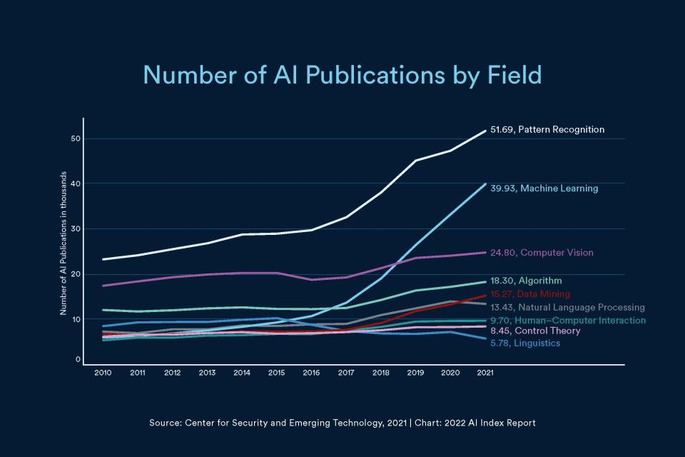

**This graph and plot has been taken from Stanford university website – where they made a research on current trend for different AI technologies.**

**The graph here shows the trends in publications made by the researchers in which Pattern Recognition takes the lead by making 51.69 publications followed by Machine Learning, Computer Vision, Algorithm, Data Mining, NLP, Human – Computer Interaction, Control Theory and Linguistics.**

**Various Fields in AI**

**The level of intelligence a Computer can possess in Artificial Intelligence can be classified into three different Categories –**

1. **Artificial Narrow Intelligence – Artificial Narrow Intelligence is the first stage of learning and training where the machine can interpret and understand a limited level. The model Is trained to perform a certain level of task only. It can have some errors and problems sometimes too. Image recognition, adding filters to faces etc are some examples. These are been used by companies for automating the tasks which helps in better efficiency. This is also called as “WEAK AI”.**

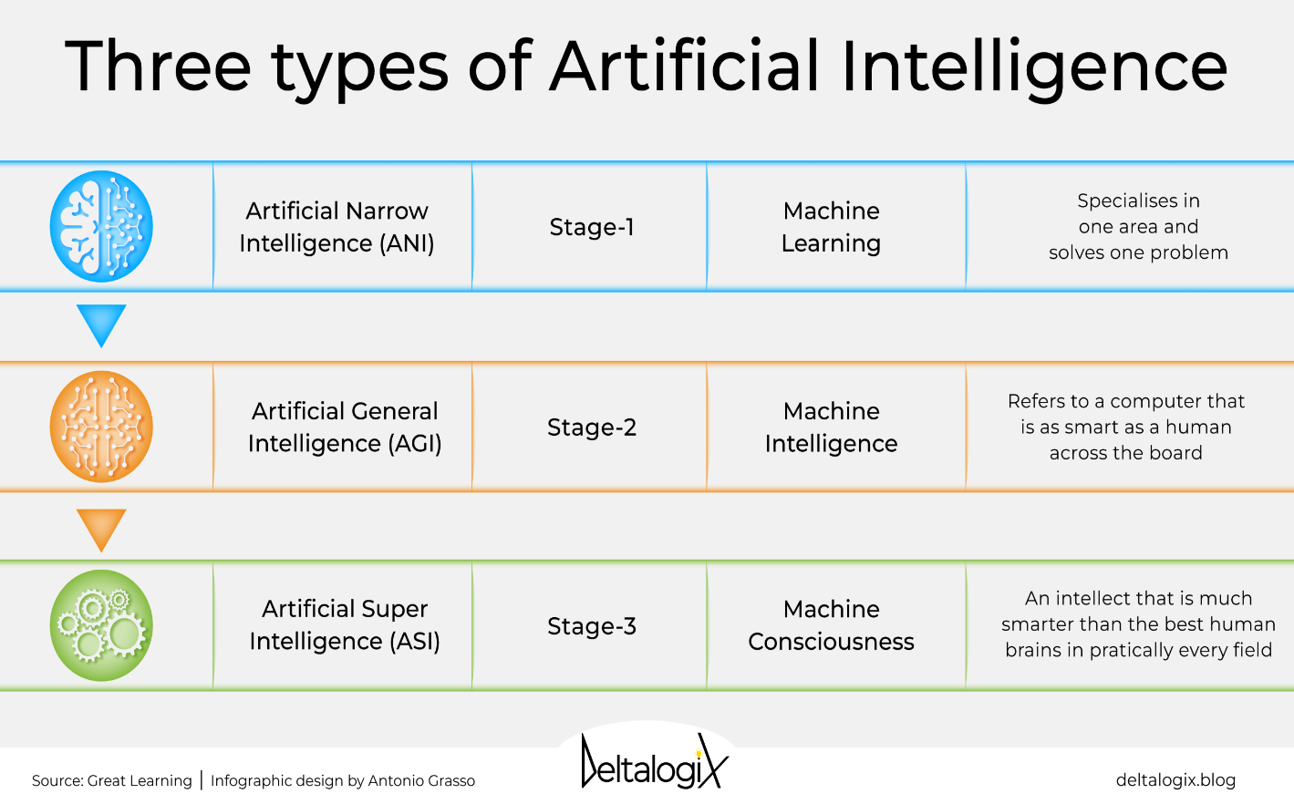

Source : <https://deltalogix.blog/en/2023/03/08/artificial-intelligence-a-look-at-its-three-types-and-their-possible-future-implications/>

1. **ARTIFICAL GENERAL INTELLIGENCE (AGI) : Artificial General Intelligence is the 2nd stage of AI, also called as Machine Intelligence. It is a level of AI that somehow reaches the intelligence level of human beings – or as said in the following picture “Refers to a computer that is as smart as a human across the board “. This “Strong Intelligence “ has broad and adaptable features. Unlike narrow AI it can solve broad level of problems . But there is still research and experimentation going on to make it more better in upcoming times as it is not completely or you can say fully developed. But one thing is needed to be made sure is that it has to be developed and designed in a way that it can work collaboratively and cooperatively with humans.**
2. **Artificial Super Intelligence(ASI) : This is the 3rd stage of AI, also called as Machine Intelligence – now I find this something as very disastrous or end of the world because at this moment the consciousness of the machines will surpass the human intelligence – now they cant be in control of anyone as they can think most of the things on their own. They have surpassed human consciousness barriers. The ASI can be made by continuous growth and recursive learning as well. But there is a lot of time for the ASI to be established but once it does it will endanger the human-kind.**

**SOME CONS OF AI ACCORDING TO MY OPINION :**

1. **Though any sort of technology is created for the betterment of the man kind and help them grow.**
2. **But if it causes a negative effect on anything then whats the point of it.**
3. **AI makes life way more easier as things get so automated by itself and life can become very easy for us.**
4. **But AI also holds the power to steal away bread from many people by replacing them.**
5. **Though for growing technology is absolutely needed but according to my opinion it should not be created in a way that can kill human kind.**
6. **Something that can help the human kind, something that should be collaborative and cooperative to the humans .**
7. **Just imagine if we reach a certain level of ASI where the robots and machines – reach beyond human consciousness- then I guess the sci – fi movies will get real.**
8. **Because we wont be any much feasible for work anymore, no use for the world.**
9. **Find the right balance is something should have to kept in check actually.**

**CONCLUSION :**

Artificial Intelligence and Machine Learning have transcended the realm of science fiction to become integral components of our modern world. The ongoing advancements in AI and ML technologies have far-reaching implications for industries, society, and human life. As these technologies continue to evolve, a balance between innovation, ethical considerations, and responsible deployment will be crucial to harness their full potential for the betterment of humanity.